Real Timer

“ Using system; “ system’s library to be added above first.

Use “ TimeSpan ‘ *desired reference name* ‘ = TimeSpan.FromSeconds( ‘ *variable name* ‘ );

**Output:- 0:00 or 00:00 as real time counter.**

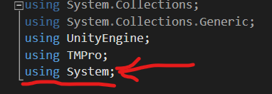

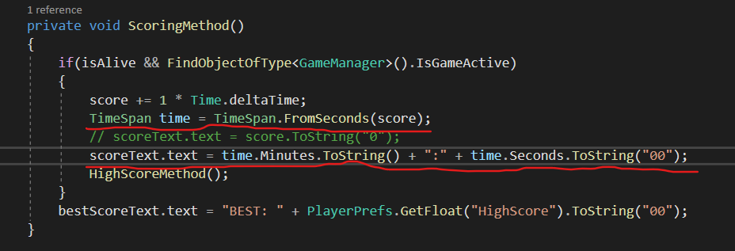

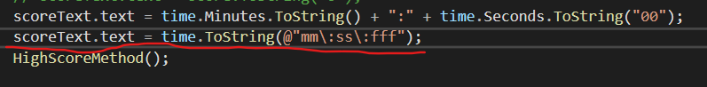

Shortcut – time.ToString(@”mm\:ss\:fff”);

Time.deltaTime is used for perfect timer to prevent system support issues.

For Storing Maximum Time Survived

You have found out your own method just follow the below code.

